Logic Design CH3

Q1

(a)

|  |  |  |  |
| --- | --- | --- | --- |
| w | x | Y | z |
| 1 | 1 | 1 | 1 |
| 1 | 1 | 0 | 0 |
| 1 | 0 | 1 | 0 |
| 0 | 1 | 1 | 0 |
| 0 | 0 | 1 | 0 |
| 0 | 1 | 0 | 0 |
| 1 | 0 | 0 | 0 |
| 0 | 0 | 0 | 0 |

Q2

W = 0

Y = 0

X = 1

Z = 0

Q3

(a) A three-input AND gate = A.B.C =D

(b) A four-input AND gate = A.B.C.D = E

(c) (c) A three-input OR gate = A+B+C = D

Q4



Q5



Q6



Q7

(A)



(B)

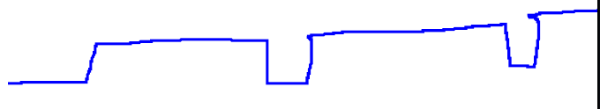

Q8

X = $\overline{A}$ Z = $\overline{X}$

X = 0

Z = 1

Q9

Y = $\overline{CD}$

|  |  |  |
| --- | --- | --- |
| C | D | Y |
| 0 | 0 | 1 |
| 0 | 1 | 1 |
| 1 | 0 | 1 |
| 1 | 1 | 0 |

Q10

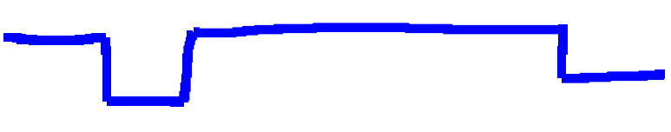

Q11

(a)

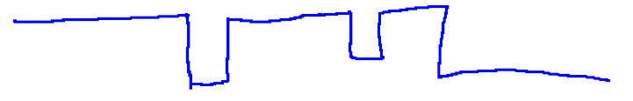

(b)



CH4

Q1

B(A+C) = X

AB+B+(B+C) * D= Z

Q2

1. R=CPF

b. G=CP(M+F)

c. B = (H+C+P)F

Q3

a.

unsimplified: 𝑃 = (𝐴𝐶 + 𝐵𝐶)(𝐴 + 𝐶)

simplified: P = A+BC

Q4

unsimplified: A((A+B).(B+C))

simplified: A((A+B).(B+C))

= A+(A+B)+(B+C)

= A+A+B+B+C

= A+B+C

Q6

(c) = = + =A + B

(d) = A + B

c and d are equivalent

Q9

Out = AB(C+D)

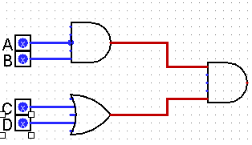

Q10

Out = A+B+C

